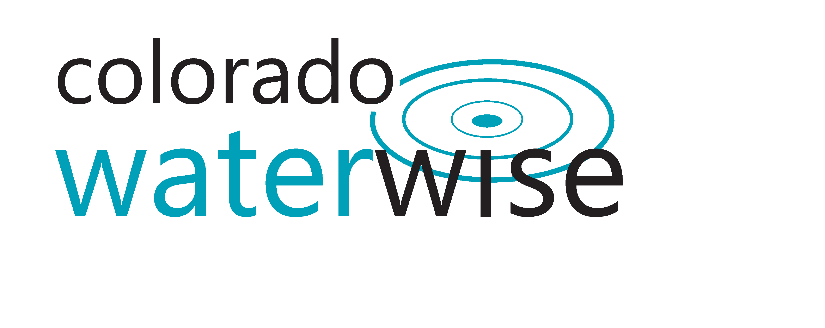
AGENDA
Colorado WaterWise Board Meeting
Thursday, August 13th 2020
10:00am-12:00pm
Virtual Only

Web Join: https://zoom.us/j/936465418
Or Telephone: 669-900-6833
Meeting ID: 936 465 418
Password: 447731

 | 10:00-10:05 am | Call to Order  - Welcome & Introductions | Co-chairs
 | 10:05-10:35 am | Board Business and Action Items  - Approval of July meeting minutes  - Trademark Update (5)  - Website Update (5)  - LLYLI Committee Update (20) | Co-chairs  Melissa/Lyndsey  Diana  Alyssa
 | 10:35-10:40 am | Review membership pitch  - See attachment | Melissa/Diana
 | 10:40 -11:10 am | Limit Assessment  - Board (15)  - Committee (15) | Diana
 | 11:10-11:40 am | Reflection of Board Expectations | Katie
 | 11:40-11:55 pm | Round Robin (15) | Board
 | 11:55-12:00 pm | Wrap Up and Adjourn | Co-chairs

Link to add hours spent on Colorado WaterWise business.

